Note on style/Style Note

When I want to indicate how many victory points, number of victory points, I write 9 VP. This means that I have 9 victory points. This is compared to writing 1 VP and 2VPs. For consistency, I write VP without the s for 1 or more than 1.

CK is used to indicate Cities and Knights/ Catan Cities and Knights/C&K.

CW is city wall.

TB is used to indicate Traders and Barbarians.

LC is legend of the conquerors.

KP means Knight point/knight points. These are fleshed out in CK and Legend of the Conquerors. Common values are basic knight is 1 KP, strong knight is 2 KP, mighty knight is 3 KP. Mighty knight with cannoneer is 4 KP. Conquerors are up to 6 KP with 5 and 6 KP conquerors seen. Cannoneer adds 1 KP.

K means knight.

DCP means defender of Catan point

Face up knight card means FUKC

Face up knight card point means FUKCP

LA is largest army

LR is longest road.

PVP is production victory point.

RB is road building card.

S means Seafarers.

If you see an abbreviation and you don’t know what it means, look at this list at the top and you should figure out what it means and find what you need.

Note. I use 3.1 instead of 3:1 when referring to port(s)/harbor(s).

LR means longest road. LTR means longest trade route.

LA means largest army.

DCP means Defender of Catan point.

When I want to indicate how many victory points, number of victory points, I write 9 VP. This means that I have 9 victory points. This is compared to writing 1 VP and 2VPs. For consistency, I write VP without the s for 1 or more than 1.

I recommend changing Catan rules and playing this way.

Set. Means settlement.

Psychologically, you are more likely to get robbed on 6 or 8 because its red than the others—5, 9, etc. Therefore, I recommend making all black or brown (brown in 5-6) to avoid any biases. That way the robber doesn’t spend the whole time on 6 or 8. I bet if you did an experiment comparing one group with black 6 and 8 and one group with red 6 and 8 there would be a difference in behavior between the 2 and there would be more robbing of 6 and 8 in the second group and the robbing would be more balanced in the first group. I understand that the intention of this is to help you out and see 6 or 8 have the highest non-7 probability, but it was a bad decision. Therefore I recommend if you are able, to play with black 6 and 8. Sometimes Catan comes with some spare circles for if you lose a number token so you can write 6 or 8 on those in black pen and use those for 6 and 8. Unfortunately, I do not that. You could cut out a piece or paper and write 6 or 8 on top. Make sure it blends in so I advise against blue ink. You could also affix the paper to a disc of cardboard if need be for more sturdy and durability because paper is flimsy. This isn’t really a problem on the computer in which case you can choose whatever you want.

One problem is if you get a 3.1 port, then another 3.1 port, you don’t get an advantage. There is a variant strong 3.1 port. This says

**Strong 3:1 Harbors**

By Dr. Reiner Düren

In the base game, there is generally no benefit to controlling more than one 3:1 harbor outside of denying another

player a 3:1 harbor for doing so. This variant introduces a concept of a “strong harbor” as a benefit for having

control of multiple 3:1 harbors.

**Variant Rules**

• A player with settlements or cities controlling at least two 3:1 harbors may trade in any three resources for

a single resource.

• As per normal trading rules, the resource being traded must be different from the three that are traded in.

The following additional rules are in effect when playing with rules from *Seafarers*. Consult with the *Seafarers*

section of the guide for more information on the mechanics found therein.

• A player may not use the “strong harbor” privilege if the pirate occupies an ocean hex such that a player

has fewer than two 3:1 harbors located on ocean hexes that are not occupied by the pirate.

I would play like this.

|  |  |  |
| --- | --- | --- |
| # of 3.1 harbors | Benefit | Example |
| 1 | Trade at 3 for 1 rate | 3 lumber for 1 brick |
| 2 | Trade 2 cards and 1 card of another type, say PPQ for target card Z. | 2 lumber 1 wool for 1 brick |
| 3 | Trade 3 cards of different type like PQR for Z. | 1 lumber 1 wool 1 grain for 1 brick. |

You could also have a limited harbor like instead of you trade at 3.1 rate for any resource, you get a deal ilke 2.5.1 or 5.2 but it only works for certain resources. So you are giving up how many resources you can use as input for a more favorable exchange rate. On the far end, you have only 1 resource and trade at 2 for 1 rate. So the options could be 3.1 any, 2.5 for 3 resources as input, you pick, or 2 for 1 resource.

For example, here I have settled a 3.1 harbor in the top right and bottom right. It would be neat to get a benefit for having 2 3.1 harbors.

The concept of production VP. The following settlement(s) city(s)

Nonproduction VP includes following LR, LTR, LA, DCP, metropolis +2, VP cards, printer, constitution

Only production VP are counted toward friendly robber threshold. The intent of the friendly robber is to enable you to get off the ground so you aren’t blocked at the beginning of the game and the start and not producing resources and you don’t get anywhere.

So if I have 2 settlements and I build 5 roads and take longest road, although I have 4 VP, I cannot be blocked or robbed. The reason is that I have 2 production VP and 2 non production VP. Not until I increase production VP can I be robbed. So maybe I build a third settlement and get 5 VP. At this point, I may be robbed because I have 2+1=3 production VP from three settlements.

An important concept with Catan games is the baseline and the ending condition.

Common baselines

|  |  |  |  |  |
| --- | --- | --- | --- | --- |
| Game | Baseline | VP |  |  |
| Catan | 2 set., 2 road | 2 |  |  |
| CK | 1 set, 1 city, 2 road | 3 |  |  |
| LC chapter 1 | 2 set, 1 city, 1 CW, 1 inactive KP | 4 |  |  |
| LC chapter 1 second try | 2 set, 1 city, 1 CW, 1 inactive 2 KP knight, politics level 1, science level 1, random politics card | 4 |  |  |

There are probably other baselines but the important point is that you have to exceed the baseline in production VP to get friendly robber protection removed. You could also add LC chapter 2 and chapter 3.

I think PVP should be the basis for deciding who’s ahead. The problem is often you get robbed a lot because you are at the front, and I think a better question is to ask who has the most PVP? Who has the most PVP and go there and rob them.

Another tip—play as a color that slips under the radar like white. Don’t play as red. You don’t want to attract attention. Blue is also good (I think). If you’re playing with a computer it doesn’t make any difference, but if you are playing with humans psychologically you get robbed more as red.

One benefit of playing online is there is a timer so you can’t take forever.

Here is how I set my preferences for board game arena.

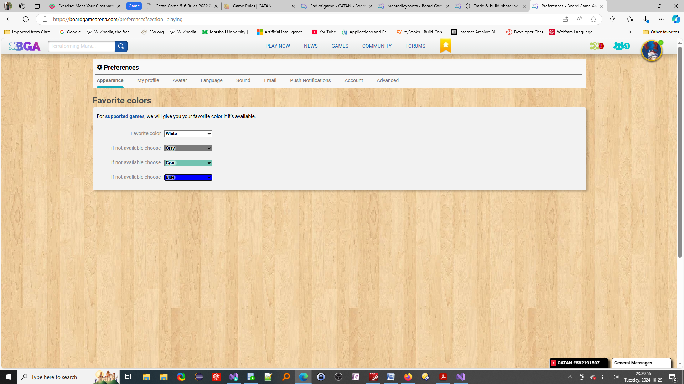

Catan expansions to play